**Black Litterman model implementation**

# Market Data

Data: Example: ( from 22/10/2013-22/10/2018) for below ccys

|  |  |  |  |  |  |
| --- | --- | --- | --- | --- | --- |
| Dates | BRL Curncy | PLN Curncy | TRY Curncy | ZAR Curncy | MXN Curncy |
| 22/10/2013 | 2.1724 | 3.0222 | 1.9673 | 9.7374 | 12.8414 |
| 23/10/2013 | 2.1906 | 3.0372 | 1.9762 | 9.7934 | 12.9965 |
| 24/10/2013 | 2.2035 | 3.0297 | 1.9799 | 9.7557 | 12.9669 |
| 25/10/2013 | 2.1878 | 3.029 | 1.9837 | 9.827 | 12.8812 |
| 28/10/2013 | 2.1787 | 3.0339 | 1.9843 | 9.8289 | 12.8764 |
| 29/10/2013 | 2.185 | 3.0461 | 1.9919 | 9.8919 | 12.9188 |
| 30/10/2013 | 2.1902 | 3.0442 | 1.9948 | 9.9455 | 12.9349 |
| 31/10/2013 | 2.2399 | 3.0807 | 1.9968 | 10.0467 | 13.0217 |
| 01/11/2013 | 2.2532 | 3.1133 | 2.0172 | 10.1898 | 13.0599 |
| 04/11/2013 | 2.2463 | 3.0937 | 2.0158 | 10.1324 | 12.9956 |
| 05/11/2013 | 2.2891 | 3.1062 | 2.0296 | 10.2444 | 13.1625 |
| 06/11/2013 | 2.2885 | 3.0871 | 2.0354 | 10.2694 | 13.173 |
| 07/11/2013 | 2.3062 | 3.126 | 2.0352 | 10.2997 | 13.2241 |
| 08/11/2013 | 2.3127 | 3.128 | 2.0383 | 10.3377 | 13.1681 |
| 11/11/2013 | 2.3313 | 3.1431 | 2.0437 | 10.3626 | 13.2155 |
| 12/11/2013 | 2.3324 | 3.1302 | 2.0552 | 10.3692 | 13.177 |
| 13/11/2013 | 2.3347 | 3.1122 | 2.0449 | 10.2797 | 13.0216 |
| 14/11/2013 | 2.3144 | 3.1144 | 2.0335 | 10.1894 | 12.9647 |
| 15/11/2013 | 2.3144 | 3.1028 | 2.0295 | 10.1605 | 12.9346 |
| 18/11/2013 | 2.2641 | 3.0912 | 2.0221 | 10.1456 | 12.894 |
| 19/11/2013 | 2.271 | 3.089 | 2.011 | 10.1826 | 12.9671 |
| 20/11/2013 | 2.267 | 3.1192 | 2.0153 | 10.1507 | 13.0924 |
| 21/11/2013 | 2.305 | 3.1119 | 2.0164 | 10.1281 | 13.028 |

# Statistics generated

|  |  |  |  |  |  |  |
| --- | --- | --- | --- | --- | --- | --- |
| **Instrument** | **Mean** | **Standard Deviation** | **VAR** | **Skew** | **Kurtosis** |  |
| BRL Curncy | 0.047588 | 1.030954 | 1.062065 | 0.190901 | 3.583111 |  |
| PLN Curncy | 0.018659 | 0.639035 | 0.408057 | 0.354085 | 2.095381 |  |
| TRY Curncy | 0.079828 | 1.039548 | 1.079845 | 2.717412 | 45.90712 |  |
| ZAR Curncy | 0.031454 | 1.006845 | 1.012973 | 0.225129 | 1.521986 |  |
| MXN Curncy | 0.037185 | 0.772885 | 0.596901 | 1.062292 | 10.7497 |  |

|  |  |  |  |  |  |
| --- | --- | --- | --- | --- | --- |
| Covariance: | **BRL Curncy** | **PLN Curncy** | **TRY Curncy** | **ZAR Curncy** | **MXN Curncy** |
| **BRL Curncy** | 1.062866 | 0.197718 | 0.321471 | 0.477903 | 0.379772 |
| **PLN Curncy** | 0.197718 | 0.408365 | 0.223987 | 0.314803 | 0.197988 |
| **TRY Curncy** | 0.321471 | 0.223987 | 1.080659 | 0.499263 | 0.318229 |
| **ZAR Curncy** | 0.477903 | 0.314803 | 0.499263 | 1.013737 | 0.457177 |
| **MXN Curncy** | 0.379772 | 0.197988 | 0.318229 | 0.457177 | 0.597351 |

|  |  |  |  |  |  |
| --- | --- | --- | --- | --- | --- |
| Correlation: | **BRL Curncy** | **PLN Curncy** | **TRY Curncy** | **ZAR Curncy** | **MXN Curncy** |
| **BRL Curncy** | 1 | 0.300112 | 0.299956 | 0.460403 | 0.476617 |
| **PLN Curncy** | 0.300112 | 1 | 0.337174 | 0.489274 | 0.400867 |
| **TRY Curncy** | 0.299956 | 0.337174 | 1 | 0.477004 | 0.396078 |
| **ZAR Curncy** | 0.460403 | 0.489274 | 0.477004 | 1 | 0.587499 |
| **MXN Curncy** | 0.476617 | 0.400867 | 0.396078 | 0.587499 | 1 |

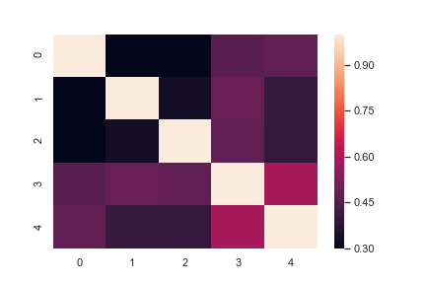

# Mean-Variance Optimization (based on historical returns)

res1 = optimize_frontier(R, C, rf)

display_assets(names, R, C, color='blue')

display_frontier(res1, color='blue')

xlabel('variance $\sigma$'), ylabel('mean $\mu$'), show()

display(pandas.DataFrame({'Weight': res1.W}, index=names).T)

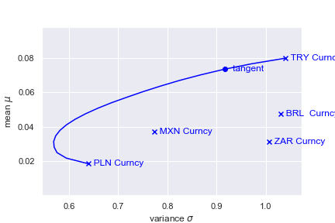

|  |  |  |  |  |  |
| --- | --- | --- | --- | --- | --- |
|  | BRL Curncy | PLN Curncy | TRY Curncy | ZAR Curncy | MXN Curncy |
| Weights | 0.197475 | 3.35831623e-17 8. | 0.802524861 | 6.70275467e-15 | 0 |

# Mean-variance Optimization (based on equilibrium returns)

res2 = optimize_frontier(Pi+rf, C, rf)

display_assets(names, R, C, color='red')

display_frontier(res1, label='Historical returns', color='red')

display_assets(names, Pi+rf, C, color='green')

display_frontier(res2, label='Implied returns', color='green')

xlabel('variance $\sigma$'), ylabel('mean $\mu$'), legend(), show()

display(pandas.DataFrame({'Weight': res2.W}, index=names).T)

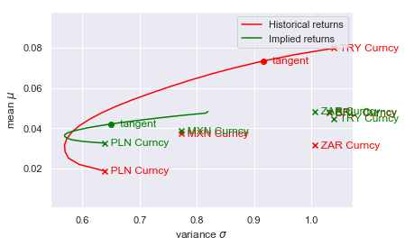

|  |  |  |  |  |  |
| --- | --- | --- | --- | --- | --- |
|  | BRL Curncy | PLN Curncy | TRY Curncy | ZAR Curncy | MXN Curncy |
| Weights | 0.258433 | 0.251927 | 0.181856 | 0.155934 | 0.151848 |

# Determine views to the equilibrium returns and prepare views (Q) and link (P) matrices

def create_views_and_link_matrix(names, views):

r, c = len(views), len(names)

Q = [views[i][3] for i in range(r)] # view matrix

P = zeros([r, c])

nameToIndex = dict()

for i, n in enumerate(names):

nameToIndex[n] = i

for i, v in enumerate(views):

name1, name2 = views[i][0], views[i][2]

P[i, nameToIndex[name1]] = +1 if views[i][1] == '>' else -1

P[i, nameToIndex[name2]] = -1 if views[i][1] == '>' else +1

return array(Q), P

views = [('MSFT', '>', 'GE', 0.02),

('AAPL', '<', 'JNJ', 0.02)]

Q, P = create_views_and_link_matrix(names, views)

print('Views Matrix')

display(DataFrame({'Views':Q}))

print('Link Matrix')

display(DataFrame(P))

Views Matrix

|  | **Views** |
| --- | --- |
| **0** | 0.02 |
| **1** | 0.02 |

Link Matrix

|  | **0** | **1** | **2** | **3** | **4** |
| --- | --- | --- | --- | --- | --- |
| **0** | 1.0 | -1.0 | 0.0 | 0.0 | 0.0 |
| **1** | 0.0 | 0.0 | 1.0 | 0.0 | -1.0 |

# Optimization based on Equilibrium returns with adjusted views

tau = .025 # scaling factor

# Calculate omega - uncertainty matrix about views

omega = dot(dot(dot(tau, P), C), transpose(P)) # 0.025 * P * C * transpose(P)

# Calculate equilibrium excess returns with views incorporated

sub_a = inv(dot(tau, C))

sub_b = dot(dot(transpose(P), inv(omega)), P)

sub_c = dot(inv(dot(tau, C)), Pi)

sub_d = dot(dot(transpose(P), inv(omega)), Q)

Pi_adj = dot(inv(sub_a + sub_b), (sub_c + sub_d))

res3 = optimize_frontier(Pi_adj + rf, C, rf)

display_assets(names, Pi+rf, C, color='green')

display_frontier(res2, label='Implied returns', color='green')

display_assets(names, Pi_adj+rf, C, color='blue')

display_frontier(res3, label='Implied returns (adjusted views)', color='blue')

xlabel('variance $\sigma$'), ylabel('mean $\mu$'), legend(), show()

display(pandas.DataFrame({'Weight': res2.W}, index=names).T)

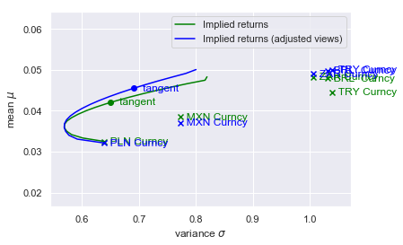

|  |  |  |  |  |  |
| --- | --- | --- | --- | --- | --- |
|  | BRL Curncy | PLN Curncy | TRY Curncy | ZAR Curncy | MXN Curncy |
| Weights | 0.300164 | 0.210175 | 0.290122 | 0.155967 | 0.043572 |